**Task 1: Rectangle verification**

Source Code

Rectangle

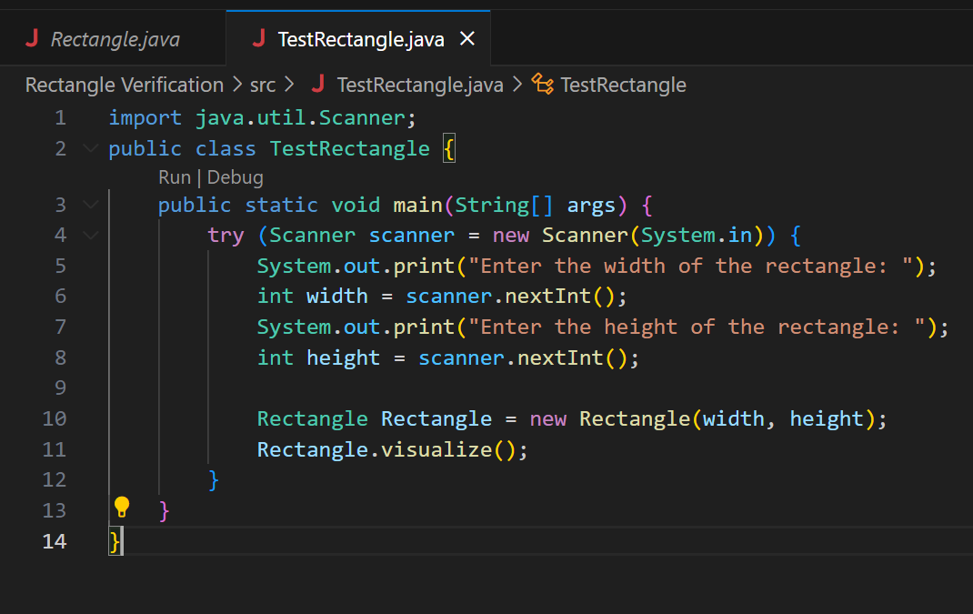

Output

**Task 2: Triangle Verification**

Triangle

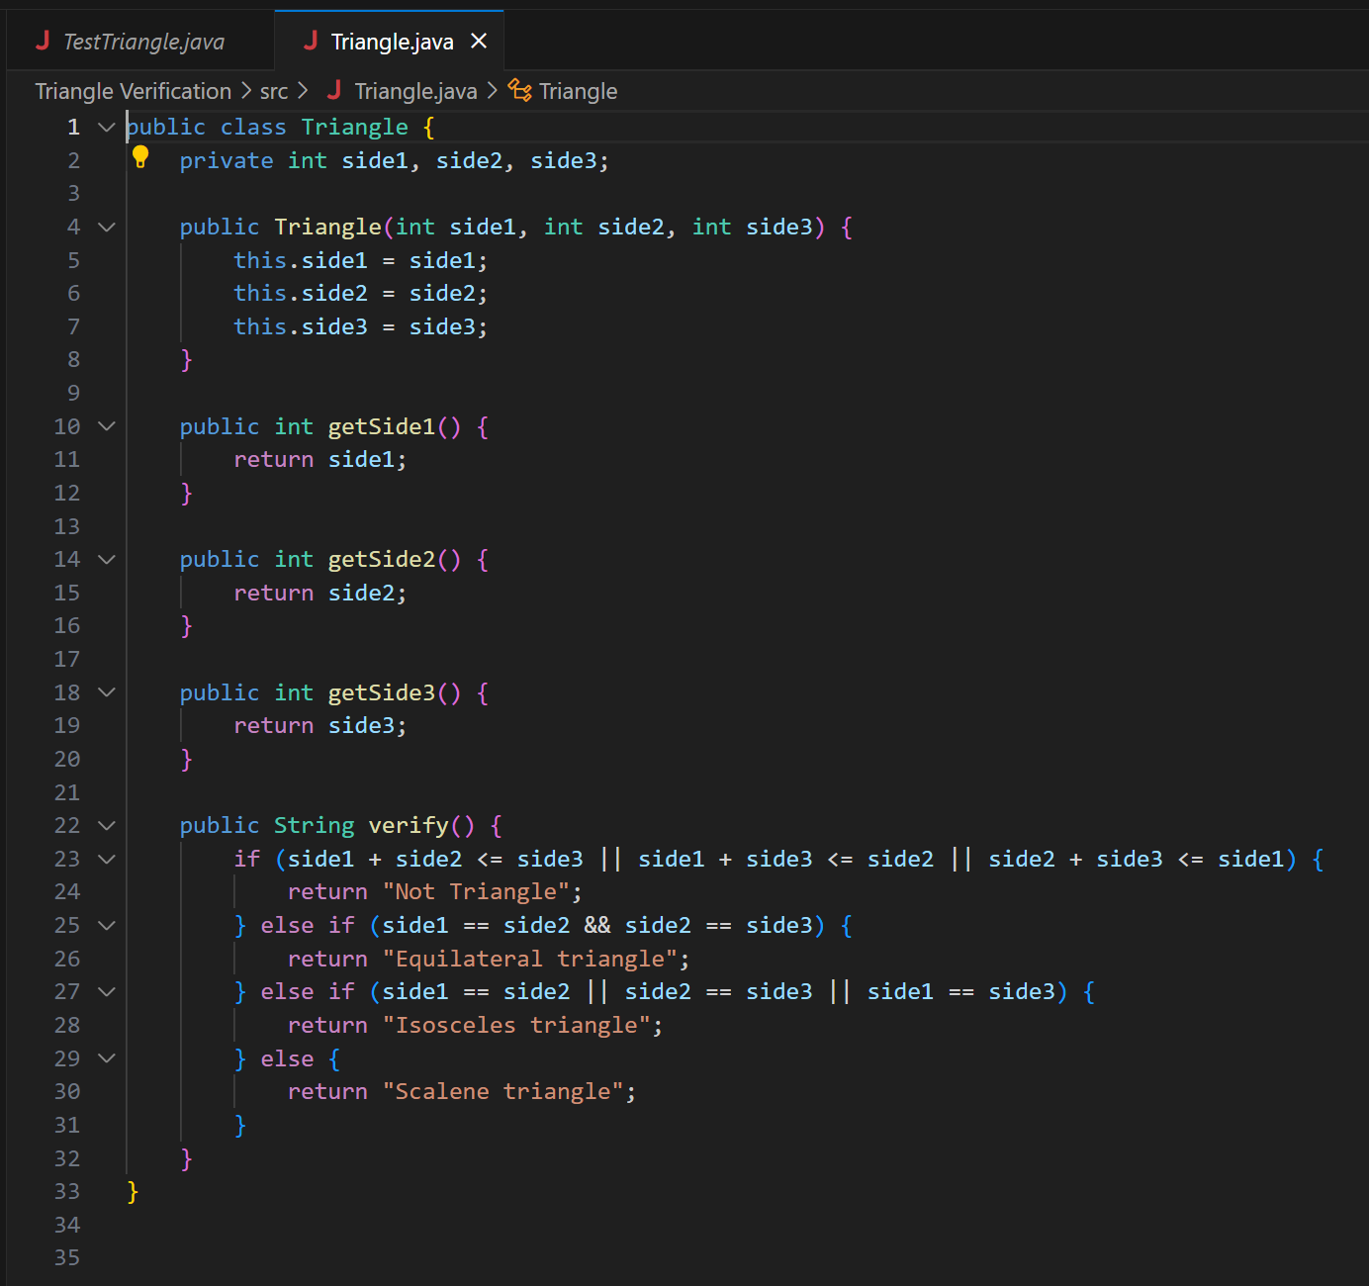

Output

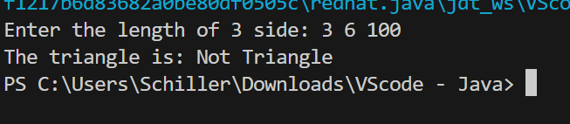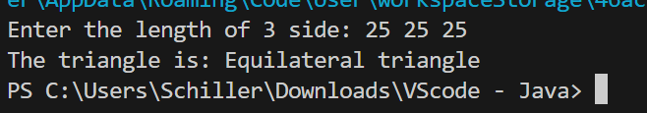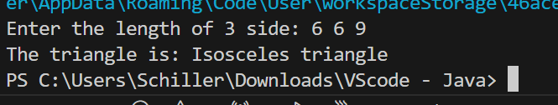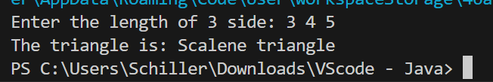

**Task 3: Distance Calculator**

Distance

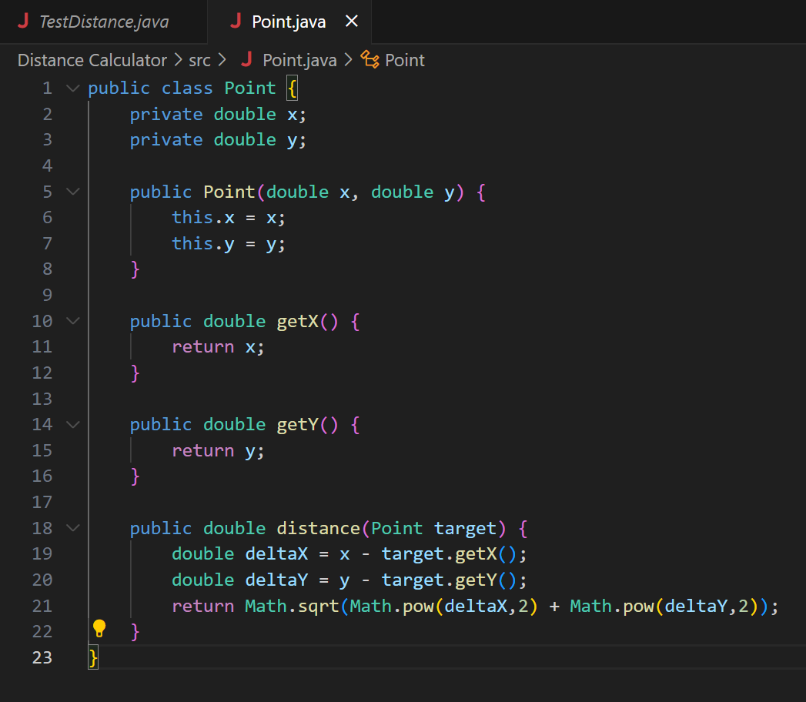 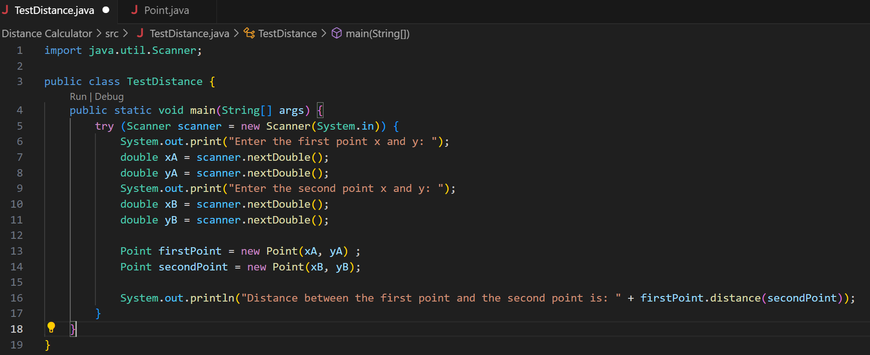

Output

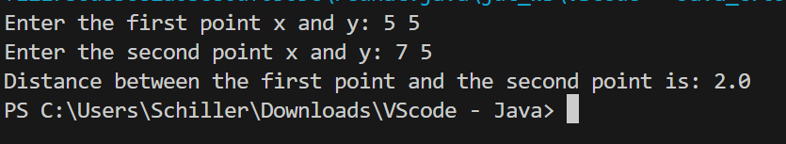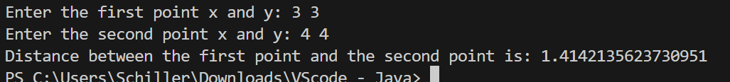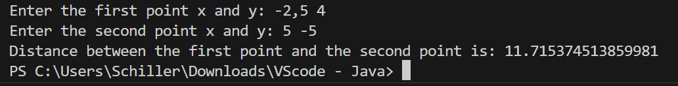

**Task 4: E-Commerce Order**

Order and Item

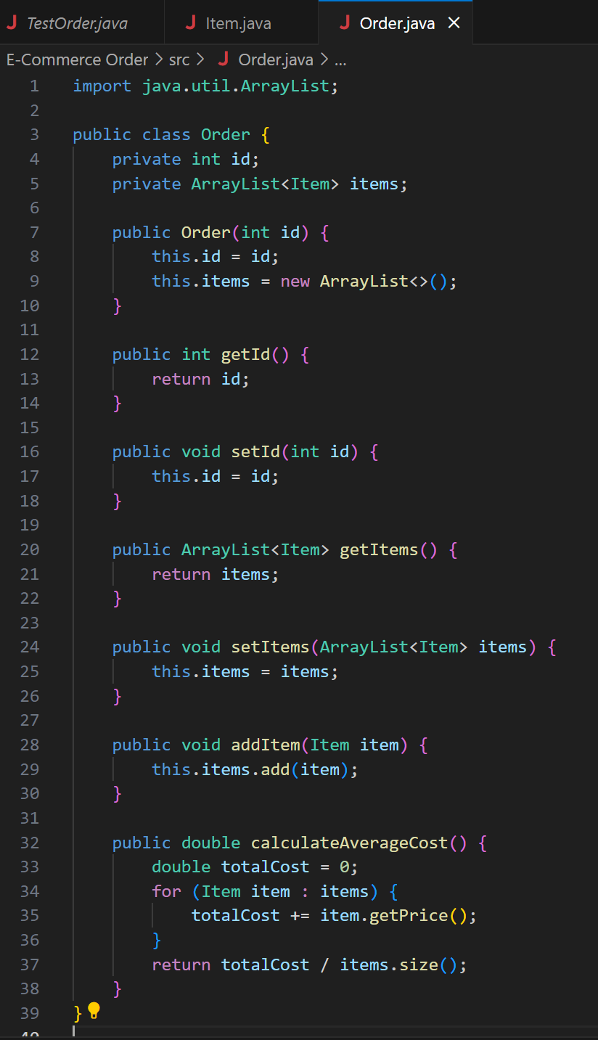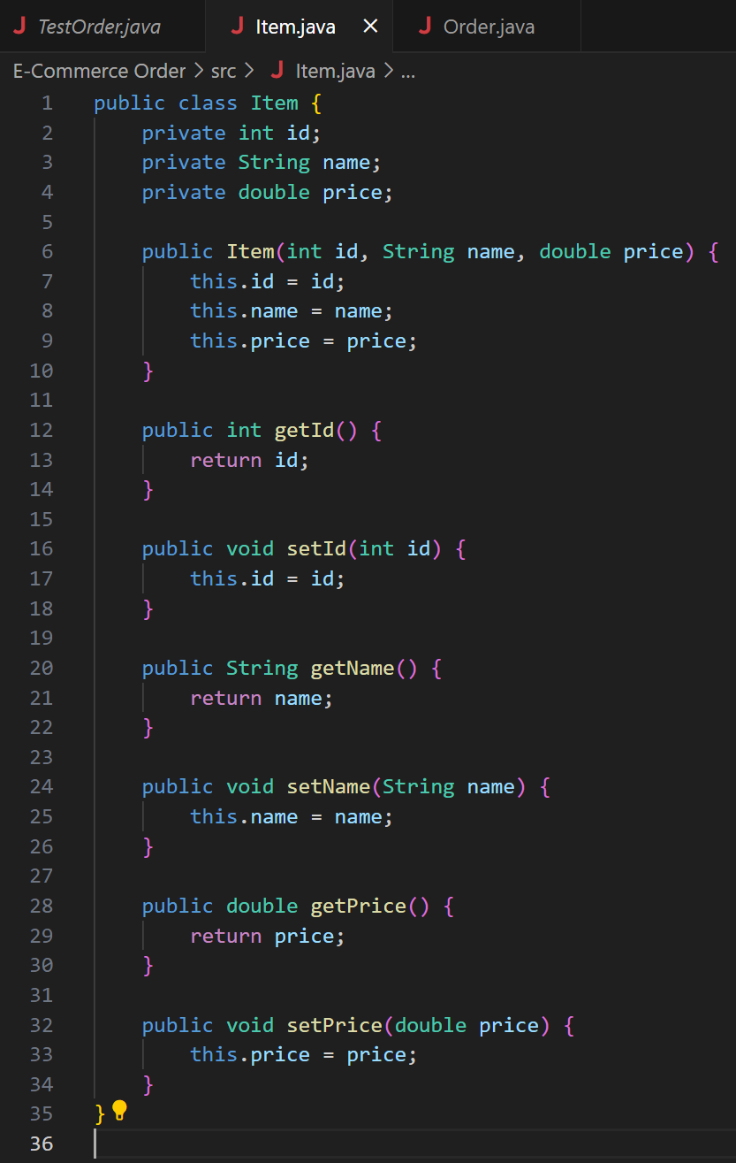

TestOrder

Output

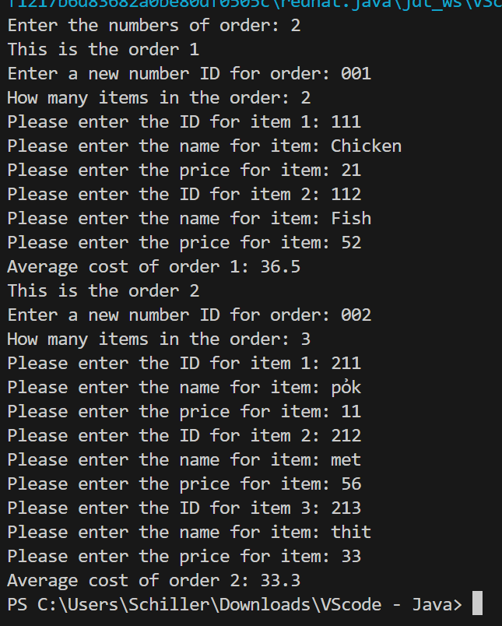

**Task 5: Tài Xỉu Online**

Player and House

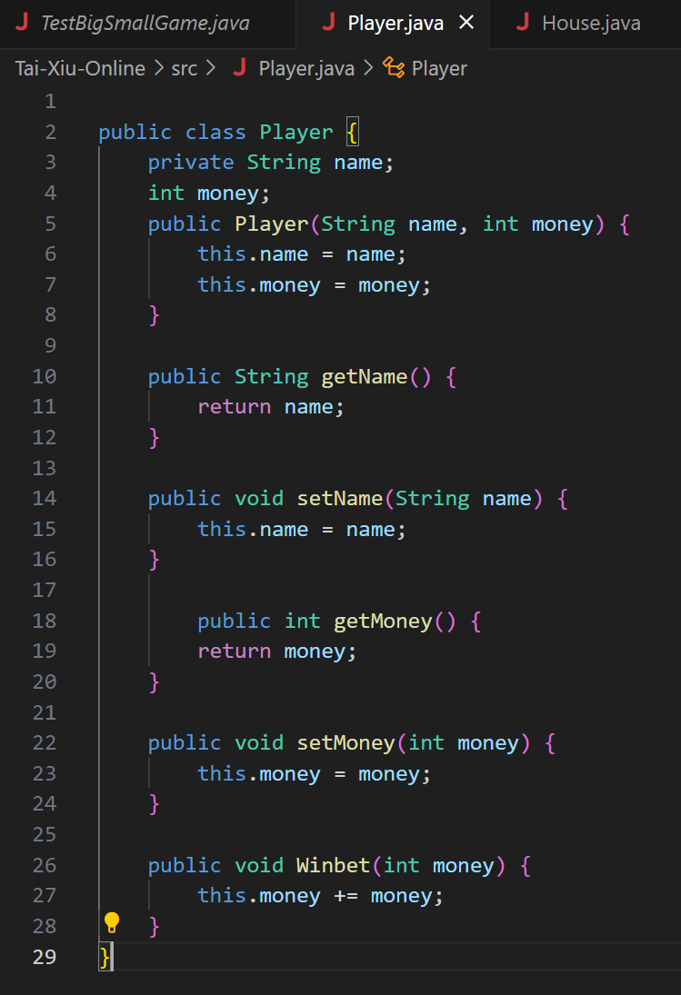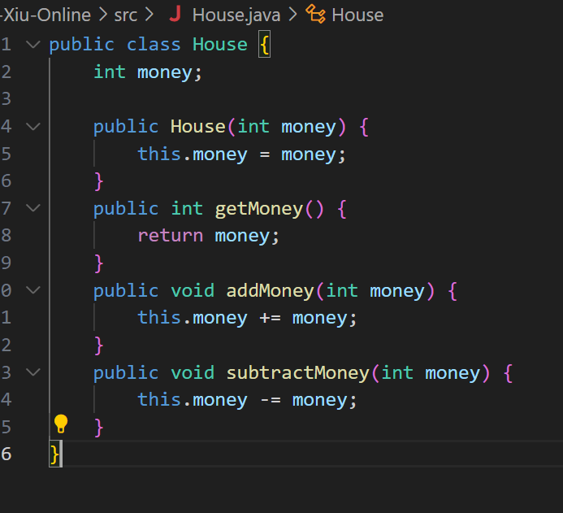

Dice

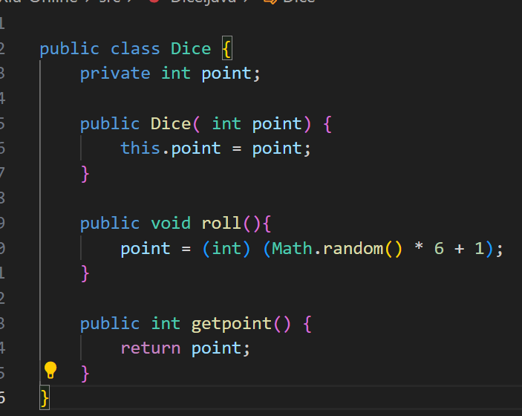

TestGame

Output

